Stake – could be on the left or right. Y will be 16” down below the stake.

CLCG Cabin Sewer Connection

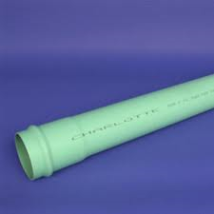

4” SDR Pipe

Sewer to Cabin B

Sewer to Cabin A

Green Box

(Optional):

4” Backwater Valve can be installed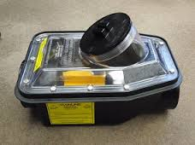

4” Expansion Joints are required to be installed vertically under cabin

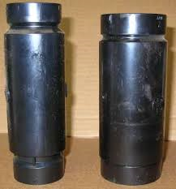

4” PVC Pipe to Cabin

Cabin B

Cabin A